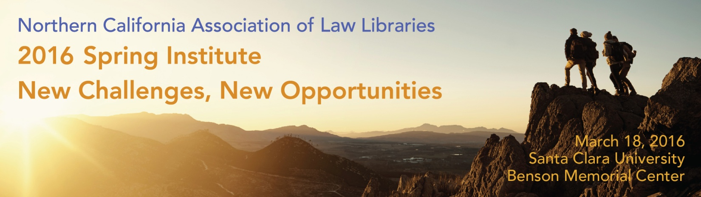
NOCALL Spring Institute 2016
Registration Form

Institute Registration & Information
March 18, 2016  Santa Clara University  Benson Memorial Center  California Mission Room | To register online, please visit: https://nocall.wildapricot.org/event-2094681  To register by mail, please make your check payable to “NOCALL” and send the check and this form to:  Michael Ginsborg  Arnold & Porter LLP  3 Embarcadero Center, Suite 1000  San Francisco, CA 94111
SpringHill Suites by Marriott San Jose Airport
Room Reservations:  Book your group rate here or call 408-650-0590.  The last day at the guaranteed rate is February 17, 2016. Do not wait until then! Book your room as soon as possible! | Room, Rate and Parking  Suite: 1 king-sized bed or 2 queen-sized beds, according to hotel availability when you check in..  Rate: $209 per night, not including local taxes and assessment fees.  Parking costs $15 daily.
Attendee Information
Name: _____________________________________  Organization: ________________________________  Address: ____________________________________  ___________________________________________  Phone: _______________ Email: ________________ | Association Membership (please circle all that apply):  NOCALL AALL SLA CLA CCCLL  Other AALL Regional Chapter: __________________

Institute Registration* Fees
General Registration (postmarked by February 18, 2016):  - NOCALL Members, AALL Members, Other AALL Regional Chapter Members, CLA, SLA, CCCLL  - Students & Retired Librarians  - Non Members  - Program, "Why Can't I Find a Job" + Lunch  Late Registration (postmarked after February 18, 2016):  - NOCALL Members, AALL Members, Other AALL Regional Chapter Members, CLA , SLA, CCCLLp[  - Students & Retired Librarians  - Non Members | $75  $30  $100  $30 ($40 after February 18, 2016)  $100  $35  $110
*Fees include program sessions, breakfast, lunch, and the reception.

Institute Parking
At the booth at the Palm Drive entrance, buy a parking permit. Park in the Main Garage.  We will have directional signs at the Garage’s exits.  - If you have mobility needs, check this box. | $7/car
Meal Selections
Please Select Meal Options:  Light breakfast (no extra fee for attendees)  Will you attend? Yes No  Lunch (no extra fee for attendees)  Will you attend? Yes No  Lunch: South of the Border Buffet.  Southwestern chips and salsa, sauteed onions and peppers, flour tortillas, salsa fresca, sour cream, cheese and cilantro-lime rice. Select one salad, one fajita, one enchilada, one side dish and assorted beverages. Dessert choices: churros or tres leches cake (Self-serve entrees can be limited to vegetarian choices.)  Please note any food allergies:  _____________________________________________ | Bringing a Guest?  Breakfast @ $10 each  List number of guests to attend: __________________  Lunch @ $20 each  List number of guests to attend: __________________  Lunch: South of the Border Buffet
MCLE Credit
Please contact Mary Staats (MStaats@fbm.com) if you expect to pursue MCLE credit for eligible programs.

Registration Total
Institute Registration Fee: $__________

Optional Guest Tickets for Breakfast and/or Lunch $___________

Total: $___________

For the latest information, visit the NOCALL Spring Institute 2016 web page at: http://nocall.org
If you have any questions about the registration process, please contact
Michael Ginsborg at 415-471-3243

