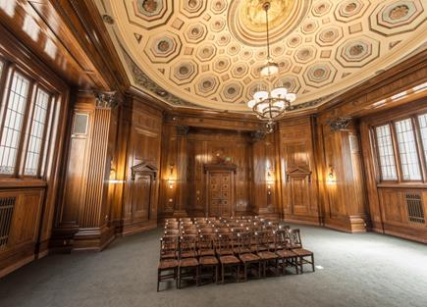
Please Join Us at the NOCALL Luncheon
Tuesday, September23 2014 at the
Stanley Mosk Library and Courts Building,
5th Floor Meeting Room
914 Capitol Mall
Sacramento, CA 95814
Directions and parking information: http://www.library.ca.gov/about/directionsdetails.html

*Vincent Beiderbecke, California State Library Photographer

Business Meeting Schedule
11:00 – 11:30 | Registration & Networking
11:30 - noon | Guest Speaker: Greg Lucas, California State Librarian
Noon -1:30 | Lunch & NOCALL Business Meeting
1:30 -- | Docents Will Be Available to Provide Building Tours
Many thanks to Carolina Rose and Legislative Research & Intent LLC (LRI) for sponsoring the NOCALL September Luncheon Meeting. NOCALL is also grateful for LRI’s sponsorship of the Friday box lunches at the 2014 Spring Institute.

Please RSVP to Jen Fell no later than Thursday, September 18th
jfell@saclaw.org or (916) 874-5296 or fax form to (916) 244-0699
Name/Affiliation ________________________________________________________________
Contact information (email and/or phone) ___________________________________________
Select your choice of sandwich:
_________ Turkey and Swiss cheese
_________ Roast Beef and Swiss cheese
_________ Super Vegy
Box Lunches Include: Sandwich, Salad, Chips, Cookie and Beverage
Cost = $15.00 per person x ________ = _______________ Total Payment Due
Payment can be sent to: Jen Fell, Sacramento County Public Law Library, 609 9th Street, Sacramento, CA 95814.
Payment will also be accepted at the door. Checks should be made out to NOCALL.

