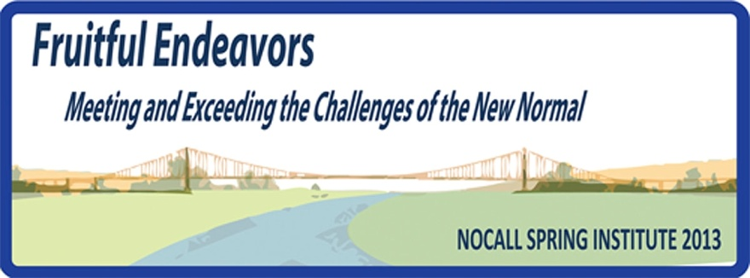

Sponsorship Opportunity Estimates for
NOCALL 2013 Spring Institute, April 12 – 13, 2013
Sacramento Holiday Inn Capital Plaza
300 J Street, Sacramento, CA 95814

Friday, April 12, 2013

- Box Lunches: $1350 approximate; final numbers will be based on registrations
  - Available 11 am to 1 pm in the Registration Area (Foyer)
  - There is an additional $10 charge per attendee to purchase one. Actual cost is $26.50, so a sponsor could subsidize by picking up the difference of $16.50. We do not have any numbers yet on how many lunches will be ordered, but usually most attendees – we expect close to 70 – will order a box lunch.
  - It is likely that there will be Round Table discussions during the pre-Institute Registration period, so attendees are interested in having lunches at these discussions.

- Friday Afternoon Break: $1300 (Bakery break)
  - Based on anticipated 70 members registered, plus vendors
  - Served in same room as meetings and Vendor Exhibits
  - Includes Coffee/Tea service, soft drinks & bottled water, plus fruit and pastry snacks

- Harness Racing Social Event + Dinner: $1300 (held off-site at CalExpo)
  - This will be an additional $15 charge per attendee. Actual cost is $25 each, so sponsorship is to subsidize the difference of $10.
Thomson
Reuters
  - Cash bar.
  - Races begin at 6 pm. Dinner is from 6:30 to 8:30 pm.
  - Buffet dinner with carving stations
  - One harness race is named for our event & attendees get photo with race winner
  - Includes admission to CalExpo Harness Race Club

Saturday, April 13, 2013

- Buffet Breakfast: $2100 (Sunrise)
  - Based on anticipated 70 members attending
  - Served in same room as meeting and vendor exhibits, 7:45 – 9:00 am
  - Includes eggs, bacon, sausage, potatoes, pastries, juices, fruit, coffee/tea, etc.

- Morning Break: $1200 (Café)
  - Served in same room as Meeting & Vendor Exhibits
  - Includes Coffee/Tea service, bottled water, soft drinks, fruit and granola bars

- Closing Luncheon: $2100 (plated), approximate; final figure based on registrations
  - Full lunch with salad, desert, coffee, tea, etc.
LEXIS
NEXIS
  - Served in room next to meeting room, 12:45 – 2:00 pm
  - Luncheon guest speaker is AALL President, Jean Wenger

- Event Technology Services (AV): $1320
  - For both days of Institute
  - Wireless Internet in Meeting Room where Vendor Exhibits located
  - Podium microphone for speakers/presenters
  - Additional Table microphones with mixer at speaker table
  - Screen and projector
  - Includes podium microphone at Closing Luncheon

All Sponsored Events will be:

- Acknowledged with Signage during the Sponsored Event
- Recognized in the NOCALL 2013 Spring Institute Brochure provided to all Attendees
- Brochure will be Included on the NOCALL Website
- Given Verbal Recognition & Thanks at Various Times throughout the Institute

